Name:  Class: | ____________________________________  ________________ |  | Date: _________
 | Year 8 Mathematics  Mini-Test 5, 2018  Topic – Circles and Algebra |  | / 39  %
Total Time: | 35 min
Equipment: | Calculator and 1 page of notes A4 (one sided). *SHOW ALL WORKING OUT*

A Grade
Determines the radius and diameter of circles, given their circumference or area and the perimeter and area of composite figures involving circles, quadrants or semicircles.
Solves a variety of problems involving circles and part circles, giving approximate or exact answers as required.
Flexibly moves between simplified and complex algebraic expressions, choosing the most appropriate form where variables are to the power of one.
B Grade
Determines the circumference, perimeter and area of circles and simple composite figures involving circles, quadrants and semicircles.
Plans and carries out the solution to practical problems involving circles, quadrants or semicircles, including those which involve more than one step.
Moves between simplified algebraic expressions where variables are to the power of one.
C Grade
Chooses appropriate formulas to calculate the circumference, in terms of diameter or radius, and area of circles in routine or familiar problems.
Solves simple and familiar practical problems involving circles.
Moves between factorised and expanded algebraic expressions involving a single numerical common factor.
D Grade
Uses formulas to calculate the circumference and area of circles, but sometimes confuses radius and diameter or circumference and area.
Attempts solutions to some practical problems involving circles, but confuses situations where circumference or area are involved.
Uses a model to simplify an algebraic expression
E Grade
Does not meet the requirements of a D grade.

Teacher Feedback:

Part A – Multiple Choice –Circle only 1 answer 9 marks
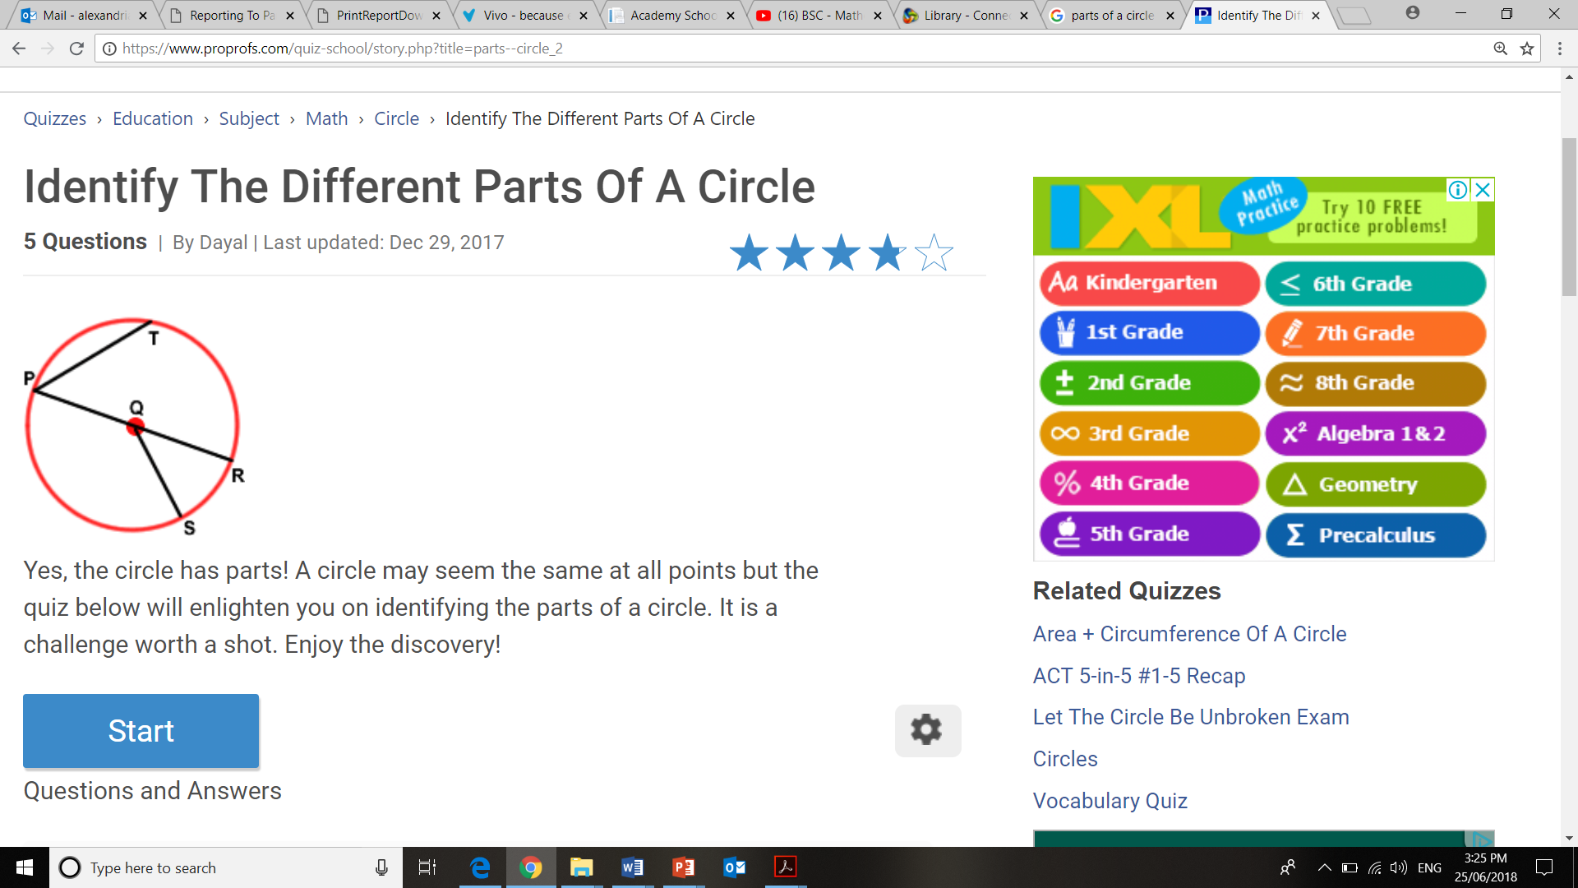
Question 1
Which of the following is the diameter?
- PT
- PQ
- PR
- SQ

Question 2
Which of the following is the radius?
- PT
- PQ
- PR
- All of the above

Question 3
The arrow is pointing to the:
- Center of the circle
- Circumference
- Diameter
- Pi

Question 4
Pi is an irrational number that is derived from:
- Circumference ÷ diameter
- Diameter ÷ radius
- Area ÷ circumference
- Circumference × radius

Question 5
A like term for 8abc is:
- 3cab
- 8ab
- 8ac
- 8bcc

Question 6
Which of the following is obtained when 3p+5+6p-2?
- 12p
- 14p+2
- 9p-3
- 9p+3

Question 7
In the algebraic expression 3x+7, which is the coefficient?
- 3x
- x
- 3
- 7

Question 8
In the algebraic expression 18ab-8b+2, which is the constant?
- 2
- 18ab
- a
- -8

Question 9
Which is the most simplified version of 3y+y+y+y?
- 3y+3y
- 3y³
- 9y³
- 6y

Part B – Short Answer ** Answer Each Question and Show Full working ** 30 marks

Question 10 [10 marks]
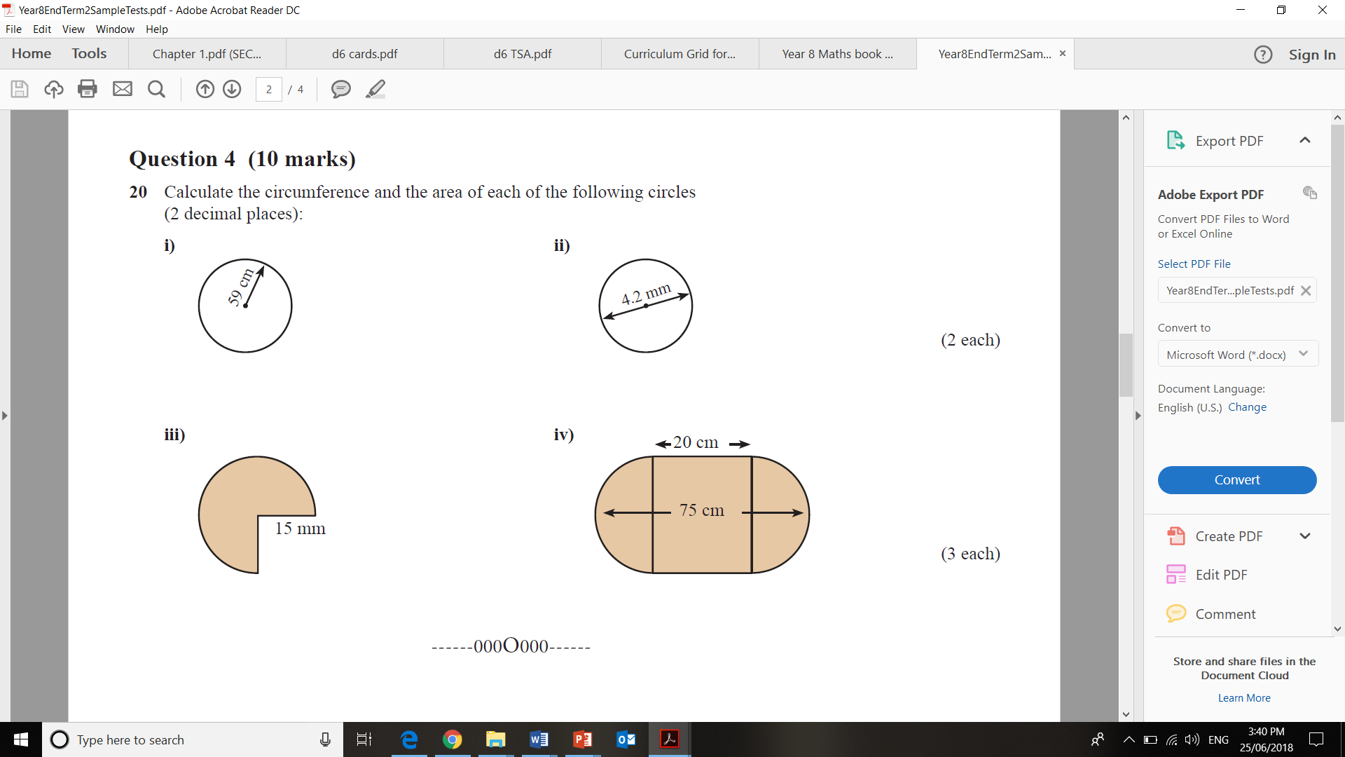
Find the circumference/perimeter of the following circles/shapes:
40 cm

Question 11 [10 marks]

Find the area of each of the following shapes:
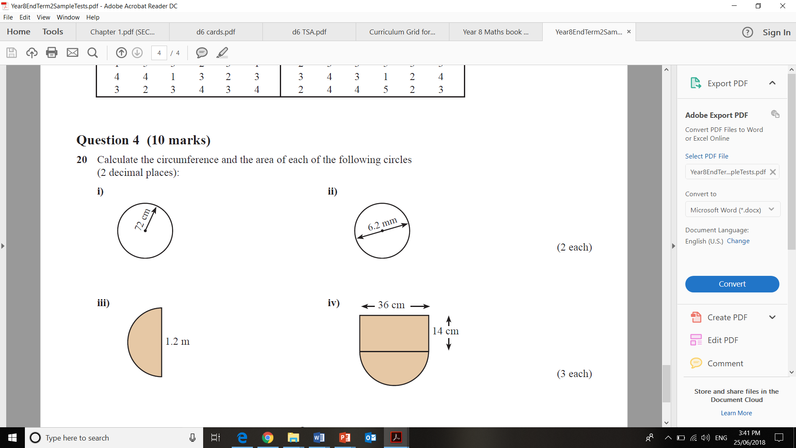

Question 12 [4 marks]
Arthur ran around a circular field 3 times. If he ran a total distance of 750 m, what is the diameter and radius of the field? (round your answer to 2 d.p.)

Question 12 [6 marks]

Simplify each expression where possible by collecting like terms.

(a) 23y – y ___________________

(b) 10ab – 7b ____________________

(c) 2a² + 5 + 6a² _______________

(d) 2x – 5x + 4 __________________

(e) 2p + 9q + 3p – 8q ______________

(f) 3m + 10 + 4n + m – 6 ________________

